**ACTIVITY DIAGRAM OF COLLEGE ADMISSION PREDICTOR:**

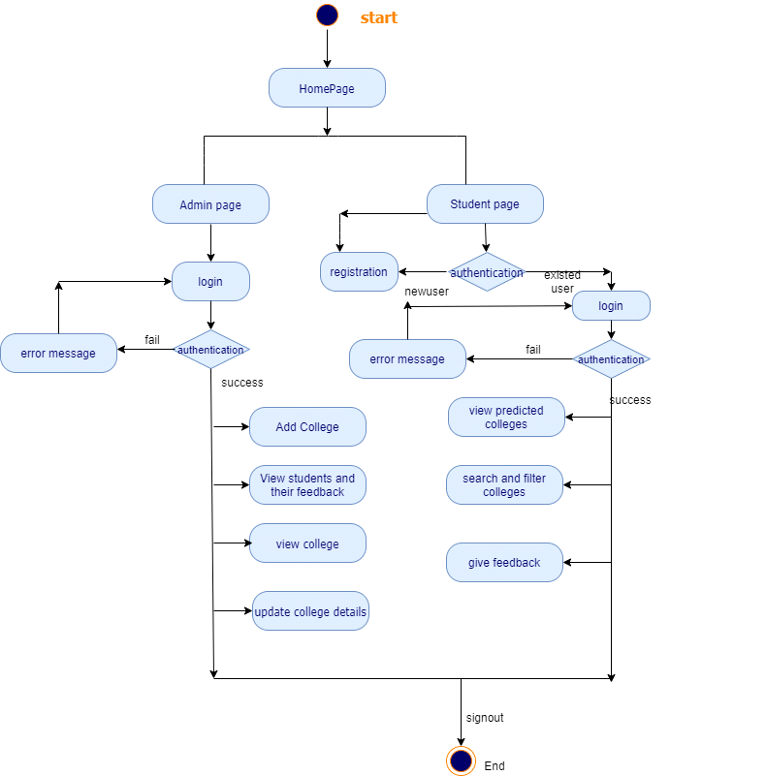

**SEQUENCE DIAGRAMS OF COLLEGE ADMISSION PREDICTOR:**

* Sequence Diagram of Registration system:

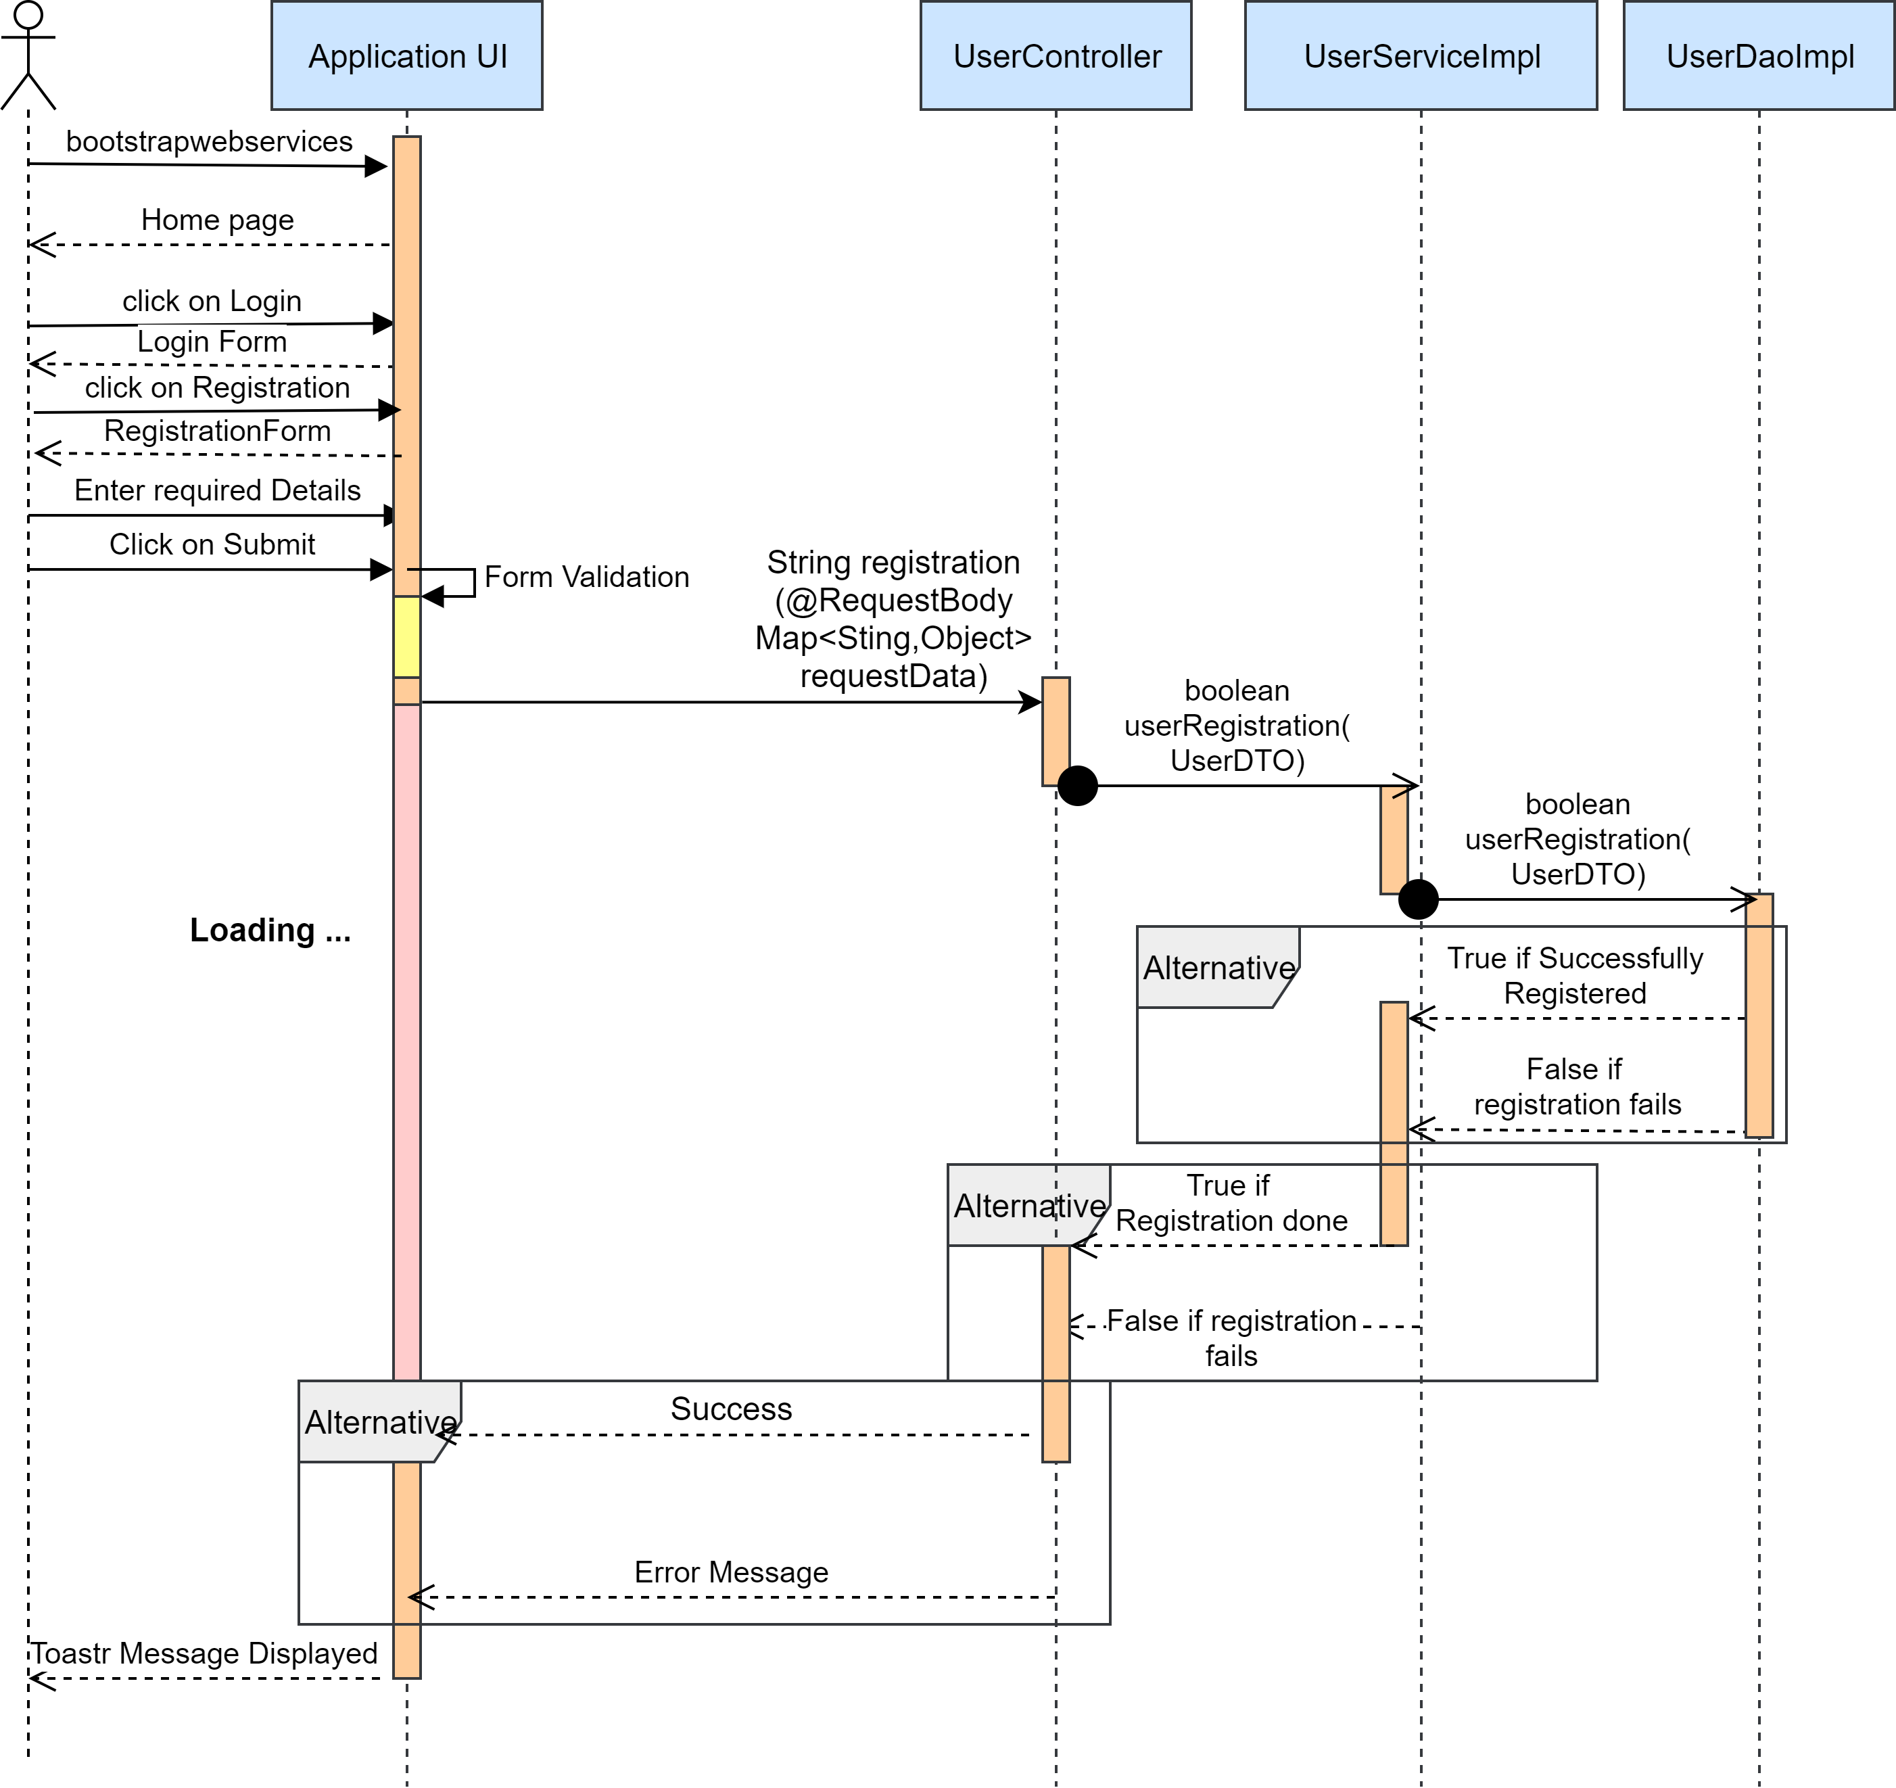

* Sequence Diagram of Login System:

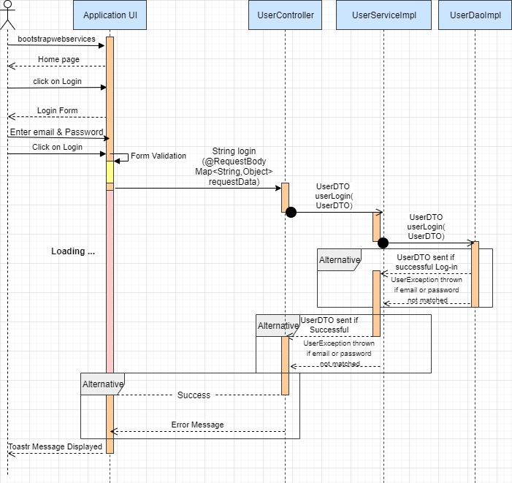

* Sequence Diagram of Logout:

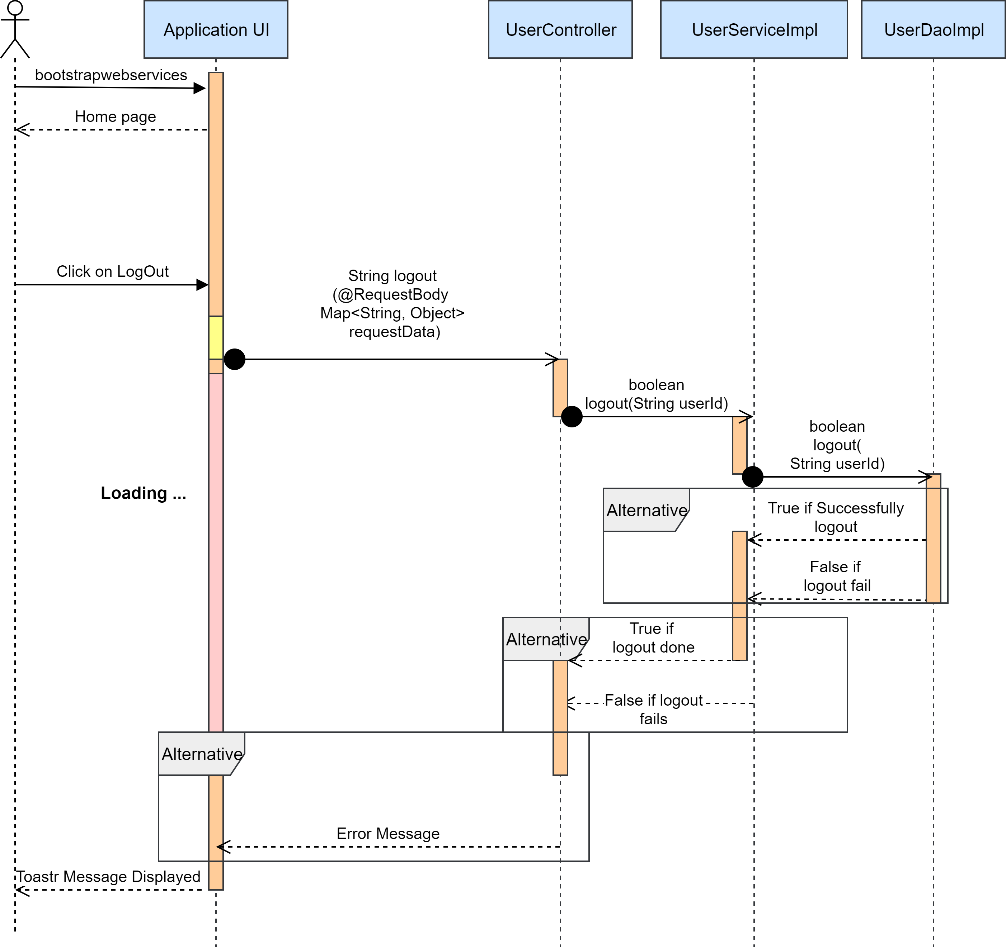

* Sequence Diagram of College exploration system:

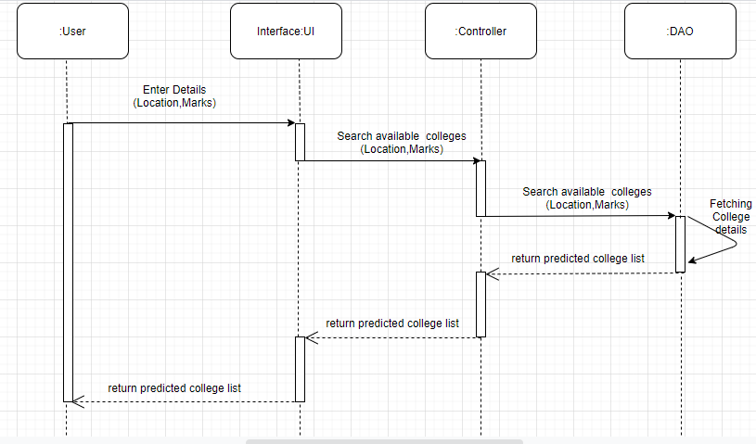

* Sequence Diagram of College Adding system:

